Experiment :- 1

Problem statement:-
Design and simulate a simple computer network using various connection topologies, namely bus, star, ring, and mesh. Compare the advantages and disadvantages of each topology in terms of data flow and network efficiency. Analyze the performance of these topologies under different network conditions.

Aim:- Design and Simulation of Computer Network Topologies
Procedure:-
- Bus topology:-

Steps:
- Open Packet Tracer
- Add PCs
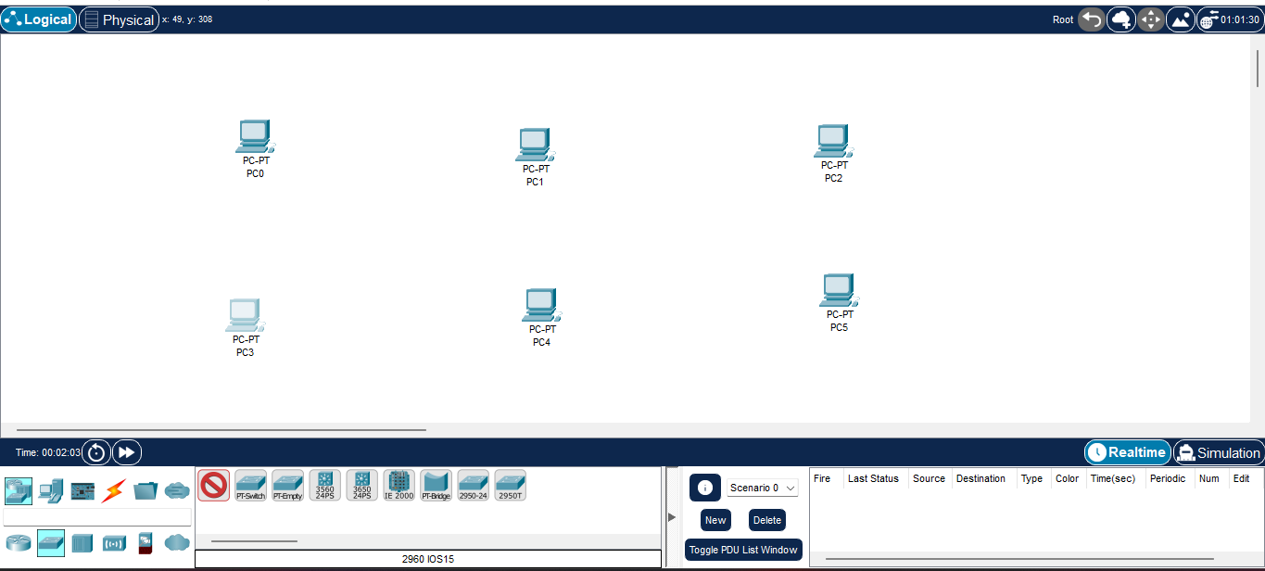
- Use coaxial cable / shared medium
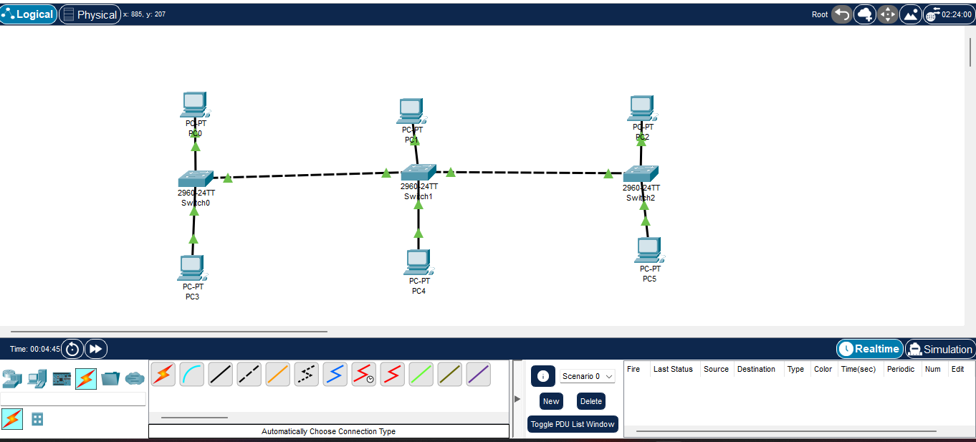

- Assign IP addresses manually

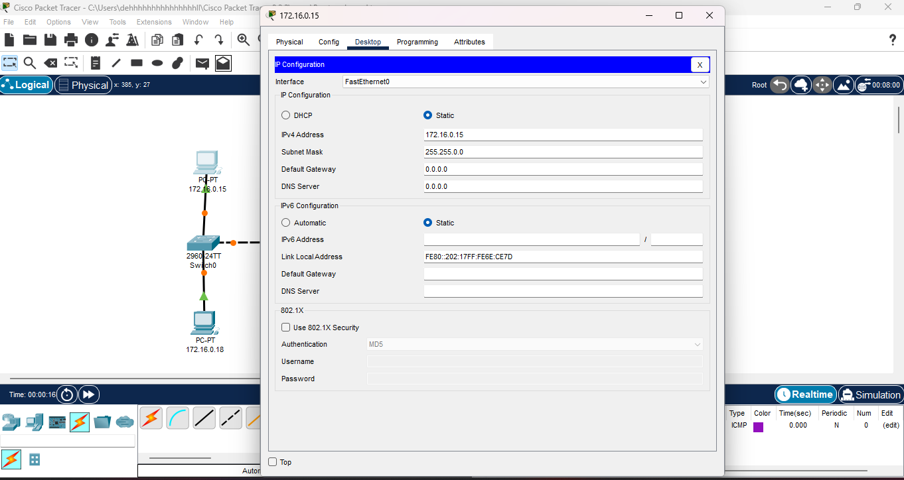
- Use ping command to test communication
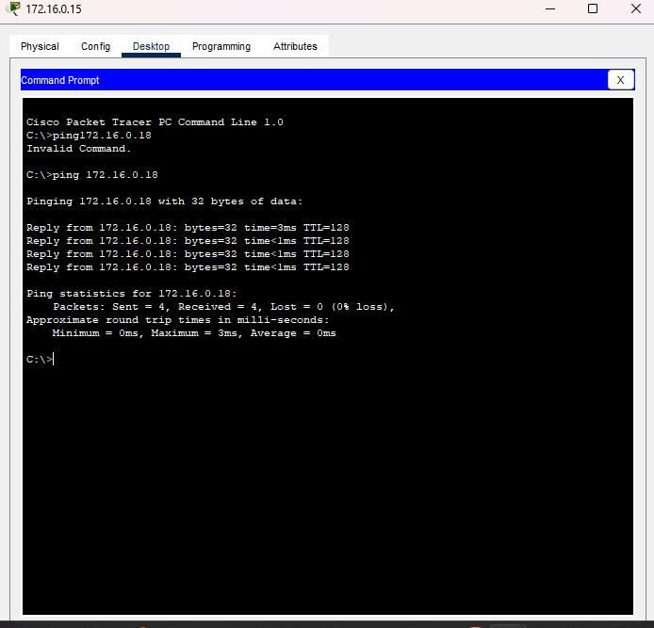
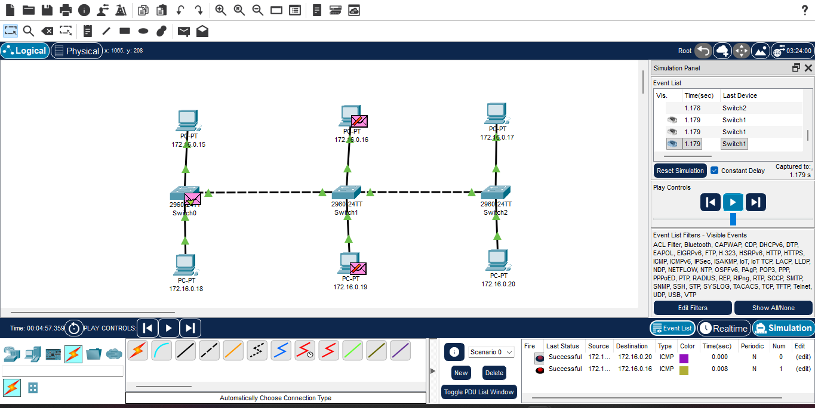
- Star topology:-

Steps:
- Open Cisco Packet Tracer
- Add 1 Switch to the workspace
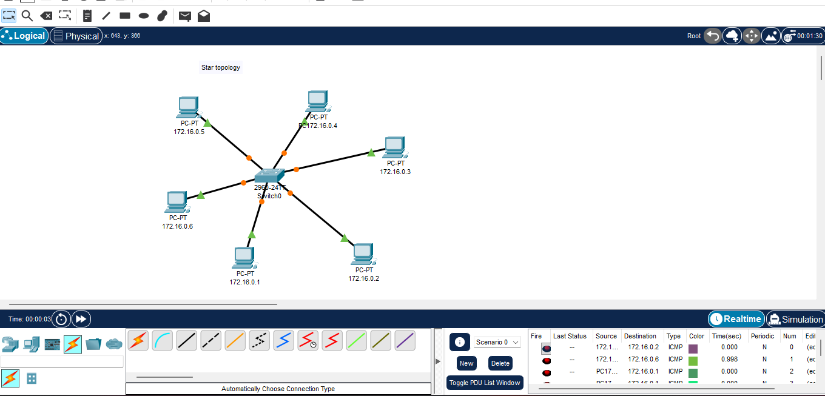
- Connect each PC to the switch using the cable

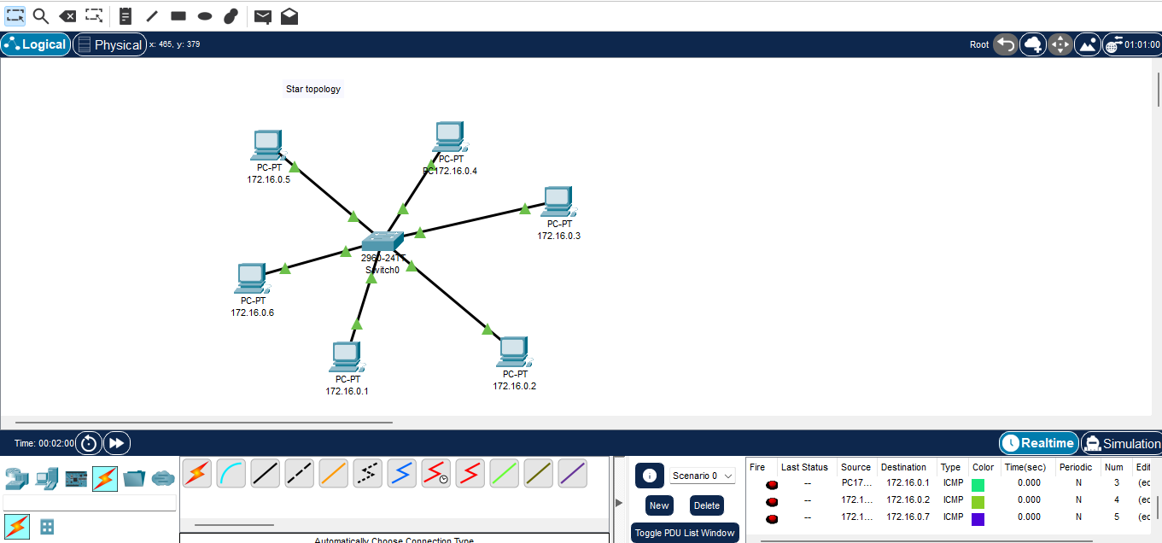
- Assign IP addresses to all PCs
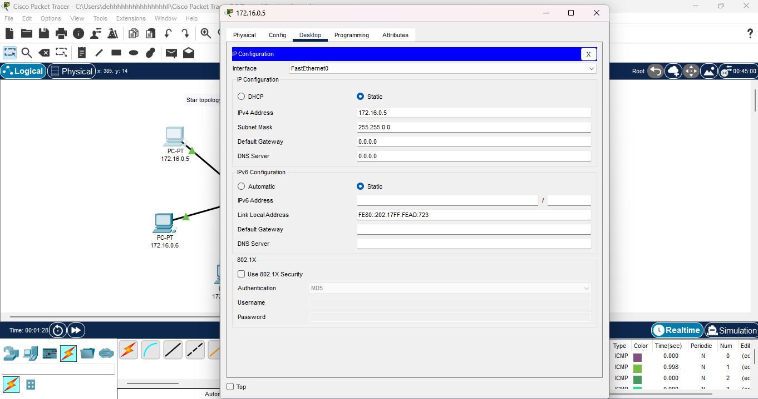
- Use ping command to test connectivity between PCs
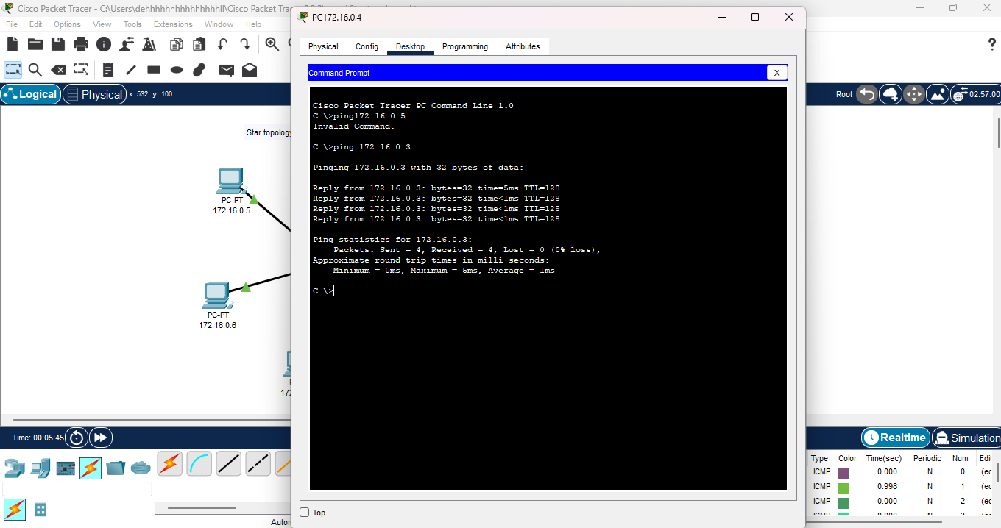

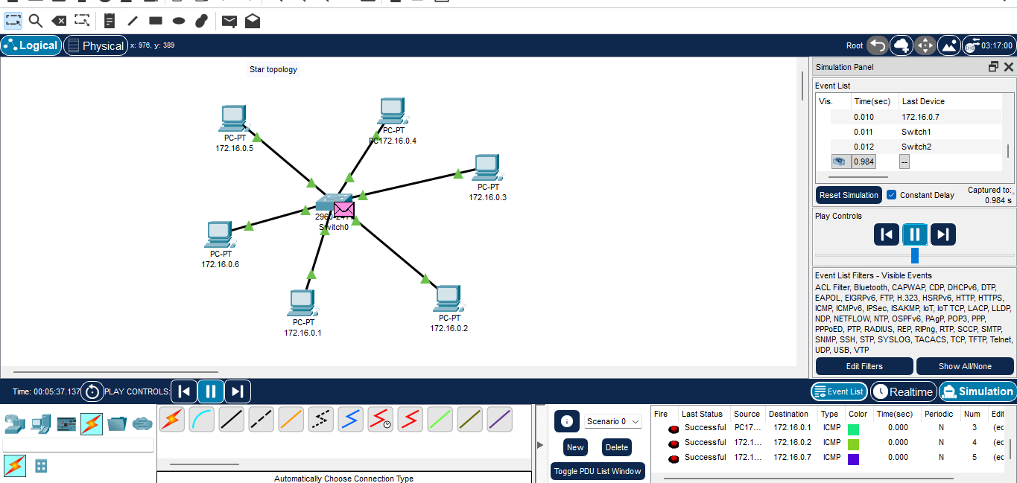
3. Ring Topology:
- Add multiple PCs
- Connect each PC in circular form
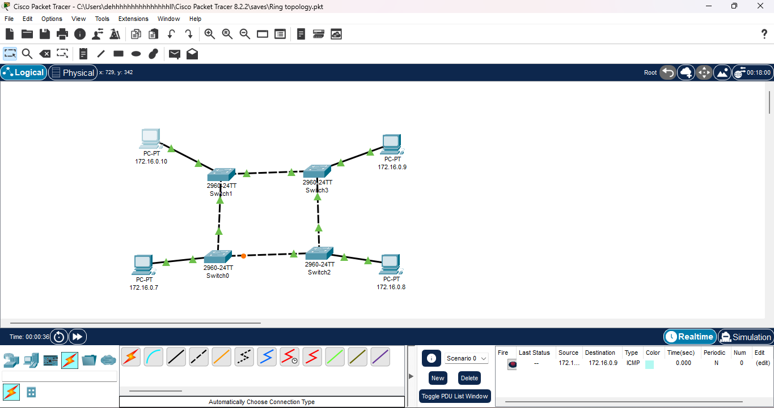
- Assign IP addresses
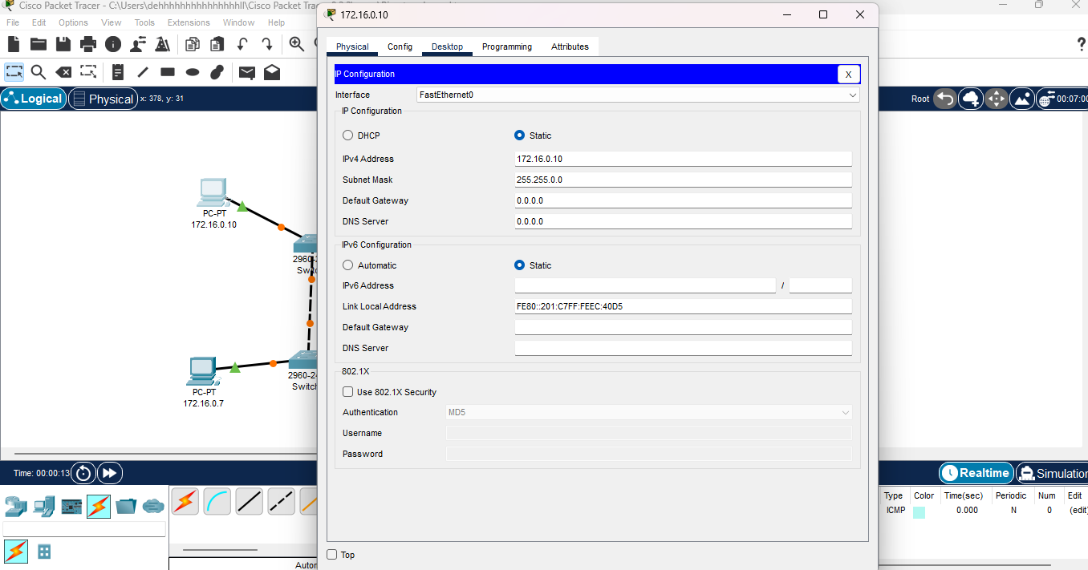
- Test communication
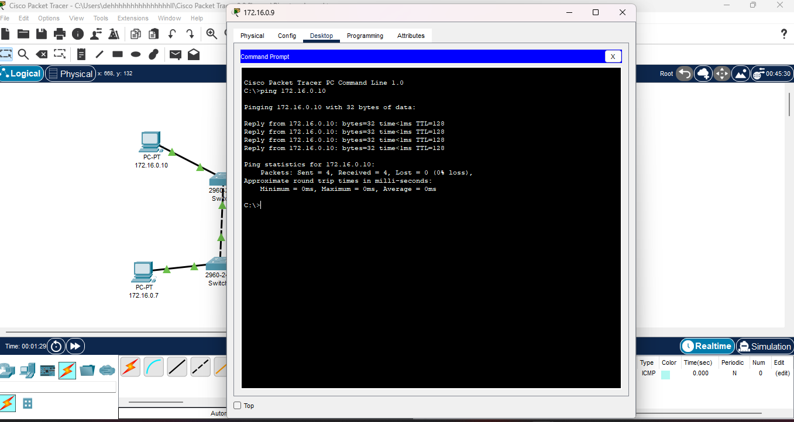

4.Mesh Topology:
- Add multiple PCs
- Connect each device to every other device
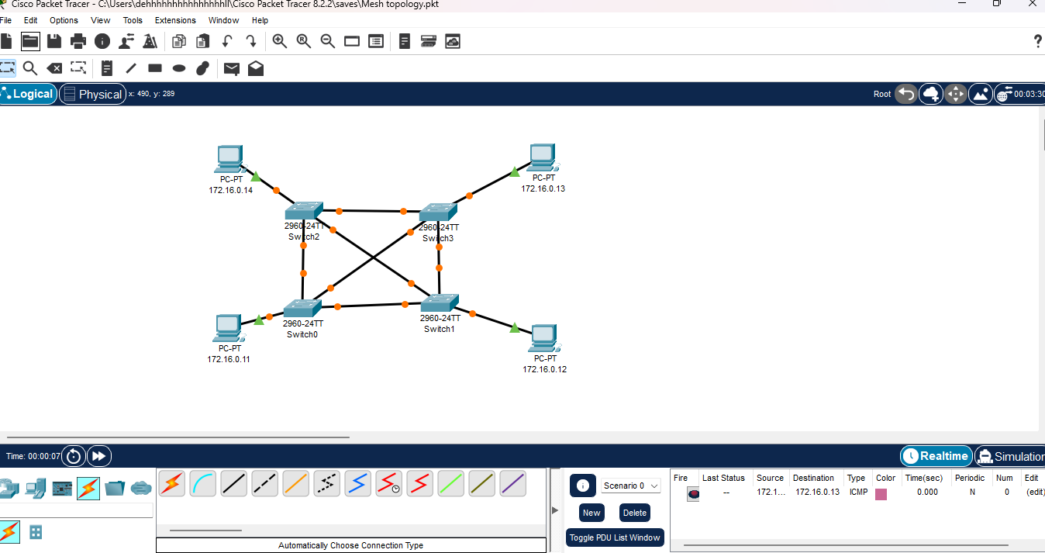
- Assign IP addresses
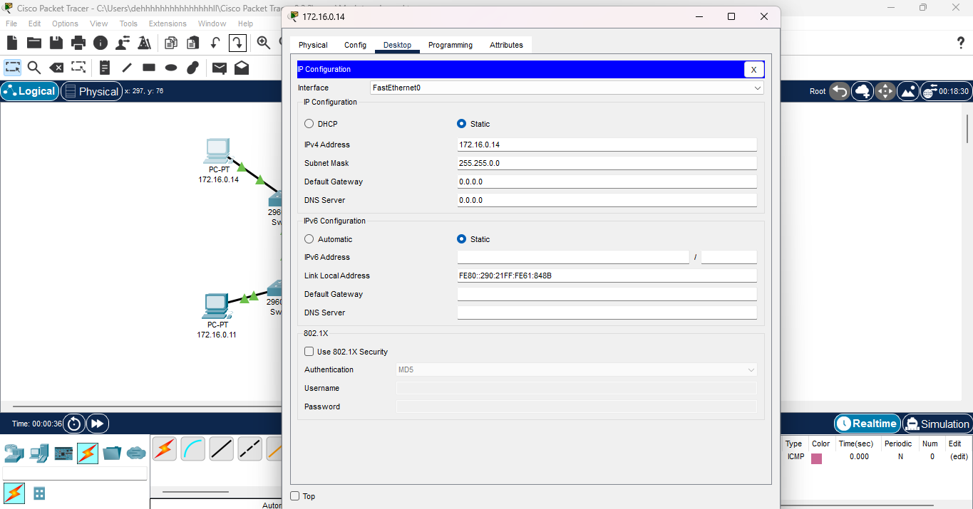
- Test connectivity
